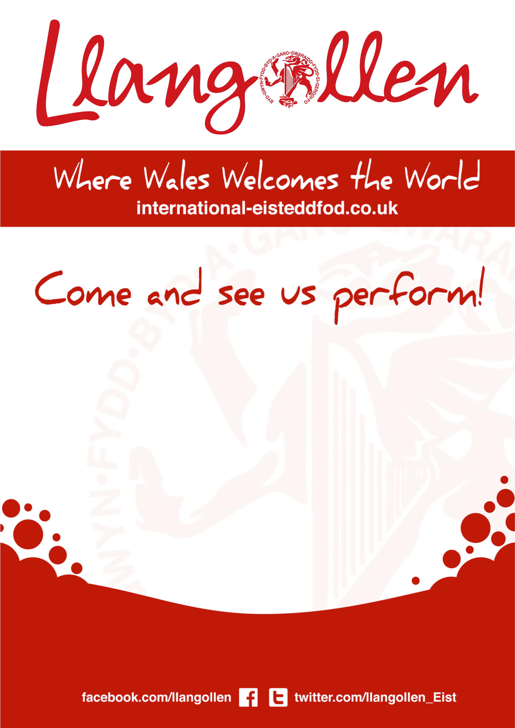

**Follow Our Progress: web address/social media**

**Short Message by Artist**

**(Photo)**

**Name of Artist**

**will perform on [Date]**

**at [Time] on the [Name of Stage]**